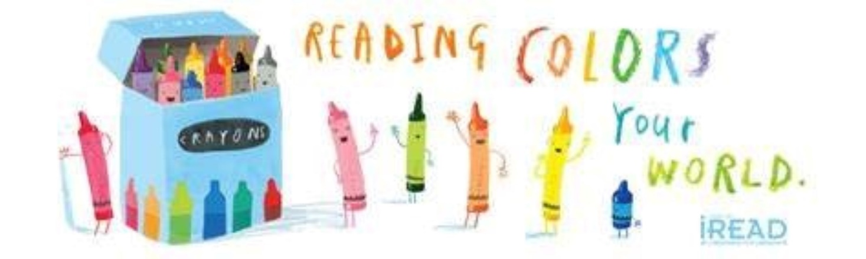
Summer Reading Program Schedule
- June 25th Bookmarks Due
- July 2nd Drawing for winning bookmark
- July 2nd Kindness rocks, call to schedule a time
- July 14th Absolute Science, The Bubble Guy 5:00pm at the main park pavilion
- July 19th Blank Park Zoo 4:00pm at the main park pavilion
- July 30th Craft day, call to schedule a time
PLEASE RSVP FOR ALL EVENTS!
YOU CAN CALL, LEAVE MESSAGE ON FACEBOOK OR VOICEMAIL!
Visit the Newhall Public Library Website and Facebook Page for more details!

