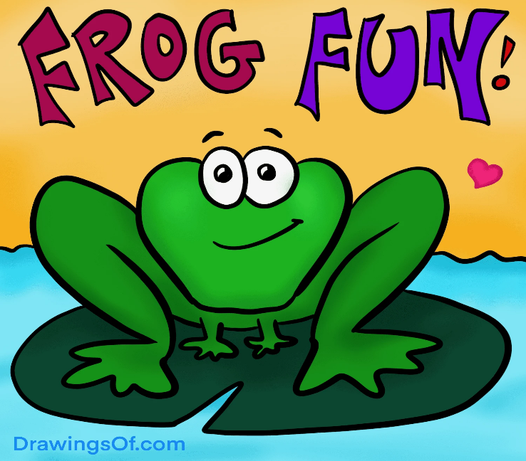
Benton County Conservation
September 27th at 4:00pm
Hop into the Newhall Library for a "ribbitting" program to learn about Iowa's amphibian friends. Participants will learn about frogs and their calls and create their own frog chorus!
No registration required. Free event.

