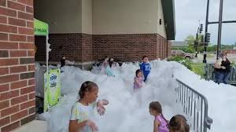

**Absolute science**

**Foam Cannon**

**July 15th**

**5:00pm**

**Main Park**

**Absolute science**

**Butterfly Tents**

**July 29th**

**4:00pm**

**Main Park**

**Cold-blooded redhead reptiles**

**July 22nd**

**5:00pm**

**Main Park**

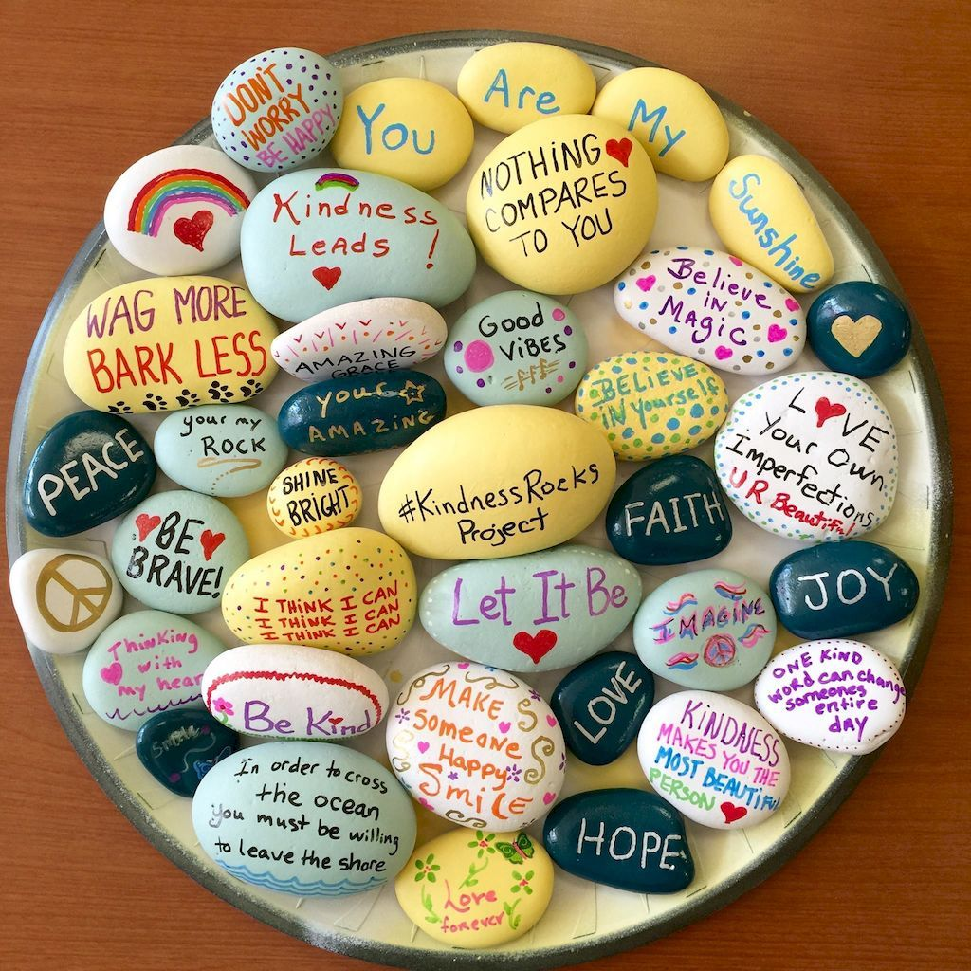

**Kindness**

**Rocks**

**July 20th**

**11- 6:00pm**

**Come into the library to paint a rock!**



**Movie Day**

**July 13th**

**10:00am**

**At Library**

**Bring a Drink**

**Snack will be provided!**

**Summer Reading Program**

**July 1st – July 31st**

**Follow us on Facebook and the Newhall public Library Website for Program schedules!**

**Come to the Library and pick up activity bags!**

**Which will include reading logs!**

**Turn in reading logs once a week to be entered in our weekly drawings!**