|  |
| --- |
| New at the Library |

ADULT FICTION

Devoted

The theory of (not quite) everything

Hail Mary

Remarkable bright creatures

West with giraffes

The spare room

The half moon

Meet me at the lake

JUVENILE FICTION

Pride and prejudice

The dog who lost his bark

Dog Man #11 twenty thousand fleas under the sea

JUVENILE NON-FICTION

Dinosaur detectives

The forest where Ashley lives

BOARD BOOKS

Peekaboo Rex!

The very hungry caterpillar’s garden friend

Hats are not for cats!

CHILDREN

The bubble book

Mango, Abuela, and me

Alma speaks up-Alma habla

Hot Dog

Kindergarten here I come!

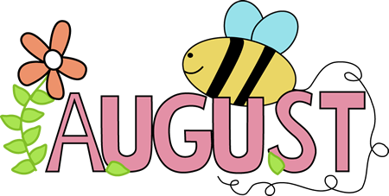

Check out our web page for the on-line adult catalog and kids catalog on the bottom left of the web page

[www.newhall.lib.ia.us](http://www.newhall.lib.ia.us)

BOOK CLUB

**Our book discussion group meets the second and fourth Wednesday of every month at 3:00 at the library. Come join us!**

RENEW ONLINE

**Our automation allows you to search our collection. If you are a library patron you can also access your own account. You can reserve, renew and update your information. Go to our web page – www. newhall.lib.ia.us and click on the catalog tab. To access your account contact the library to see how easy it is to renew online.**

Check out our web page for the on-line adult catalog and kids catalog on the bottom left of the web page

[www.newhall.lib.ia.us](http://www.newhall.lib.ia.us)

FOLLOW US ON FACEBOOK

For all programs and updates

Newhall Public Library