|  |
| --- |
| New at the Library |

DVD

Book Club the next chapter

ADULT FICTION

Everyone here is lying

The Paris apartment

Homecoming

Take what you need

The IT girl

Things I wish I told my mother

CHRISTIAN FICTION

Letters of Trust #1

Letters of Comfort #2

JUVENILE NON-FICTION

Dolly the fire dog

Mega Machines Level 1

CHILDREN

Are you a hot dog?

Pete the cat construction destruction

WooHoo! You’re doing great

If you laugh, I’m going to start this book over

Dirt Machines Heavy-Duty Construction

A letter from your teacher, on the first day of school

Time for school, little blue truck

Little yellow bus

Dear Teacher

CHILDREN CONTINUED:

Giraffes can’t dance (hardcover & board book

The tale of the whale

The secret life of squirrels

Charlie’s dirt day

Superworm

Made by Maxine

You are ready! The world is waiting

BOARD BOOK

Team Colors

Construction site friends

Vroom, Vroom, Trucks!

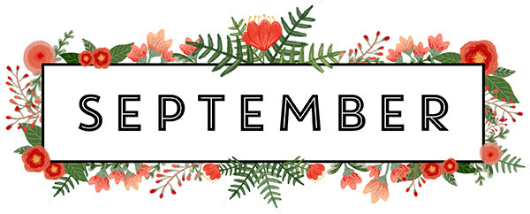

BOOK DISCUSSION GROUP

**Our book discussion group meets the second and fourth Wednesday of every month at 3:00 at the library. Come join us!**

RENEW ONLINE

**Our automation allows you to search our collection. If you are a library patron you can also access your own account. You can reserve, renew and update your information. Go to our web page – www. newhall.lib.ia.us and click on the catalog tab. To access your account contact the library to see how easy it is to renew online.**

Check out our web page for the on-line adult catalog and kids catalog on the bottom left of the web page

[www.newhall.lib.ia.us](http://www.newhall.lib.ia.us)

FOLLOW US ON FACEBOOK